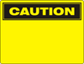 | 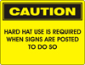 | 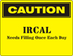 | 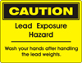 | 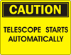
Safety-Caution.jpg | Safety-Caution Hard Hat.jpg | Safety-Caution IRCAL.jpg | Safety-Caution Lead Hazard.jpg | Safety-Caution Tele Automaticaly.jpg
 | 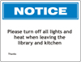
Safety-Notice.jpg | Safety-Notice Library.jpg
 |  | 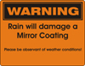
Safety-Warning.jpg | Safety-Warning Overhead Work.jpg | Mirror-Warning.jpg
 | 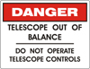 | 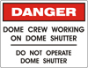 | 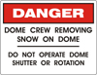 | 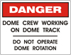
Safety-Danger.jpg | Safety-Danger Balance.jpg | Safety-Danger Dome Shutter.jpg | Safety-Danger Dome Snow.jpg | Safety-Danger Dome Track.jpg
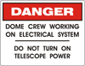 | 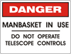 | 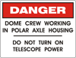 | 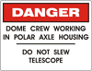 | 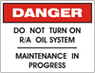
Safety-Danger Electrical System.jpg | Safety-Danger Manbasket.jpg | Safety-Danger Polar Axle.jpg | Safety-Danger Polar Axle Slew.jpg | Safety-Danger RA Oil System.jpg

Signage files are located on the CD document copy.
Signage originally drawn using CorelDRAW 10.

